C++ TIC-TAC-TOE LAB REPORT

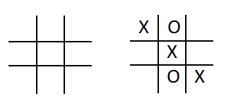
1) Enter your name, student ID, platform (Mac or PC) and date
Name and Student ID: Edgar Hernandez A0000028934
Class: SP18-CS445CA
Compiler or IDE:
Platform (Mac or PC): PC
Date: 1-31-2018

DESCRIPTION
Create a program using a two dimensional vector and functions that lets two players play the tic-tac-toe game. The program is to read a number from 1 to 9 from the keyboard alternating between the X and the O. Ask which square the X player wants, and then ask which square the O player wants. Continue until the game is won by either player, or all the squares have been filled (Called a Cat's Game).

A function must be used to display the tic-tac-toe game board (shown below), and a function must be used that determines if the game has been won. There are eight ways to win with either X or O, as shown below

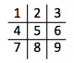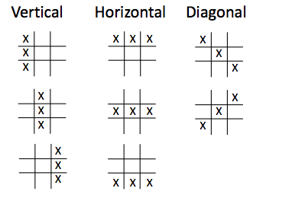

Use stacks to display all the steps played at the game in the same row, as shown below.

Steps 1 - 6
X - - X - - X X - X X O X X O X X O
- - - - O - - O - - O - X O - X O -
- - - - - - - - - - - - - - - O - -

Player O won!!!

DISCUSSION
3) Complete the DISCUSSION section. It does not need to be long, but it needs to be complete.
3a) What did you do to develop the program? ("Followed the Directions" is not a complete description)
I was at first looking around to get an idea on how to get this started. Then after a while I remembered that I have done a simple Tic-Tac-Toe program a few years ago and I just picked up from there.

3b) What problems did you have and how did you overcome the problems?
To me the mane problem was getting the 2d vector in the what the assignment wanted it. Until I found something that help me but I ended up getting it backwards. Hope that okay.

PROGRAM OUTPUT
4) Show screen shots for at least FOUR sample games: 1) a win going across, 2) a win going down, 3) a win going at a diagonal, 4) a tie game in which there was no winner.
Refer to previous lab assignments for instructions on how to capture a screen or portions of a screen for either the PC or a Mac
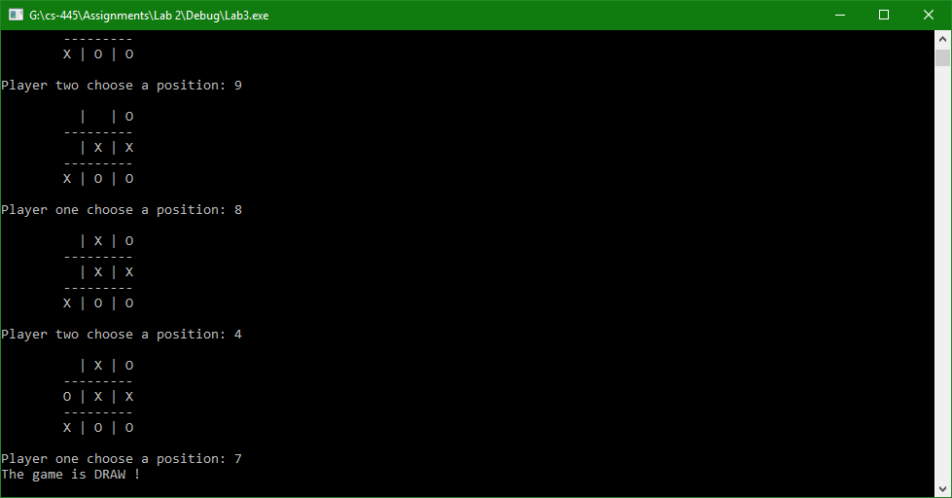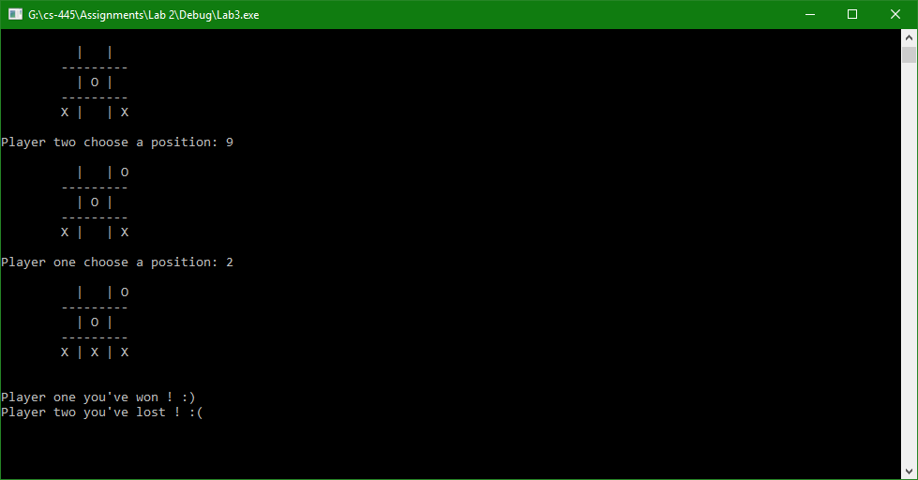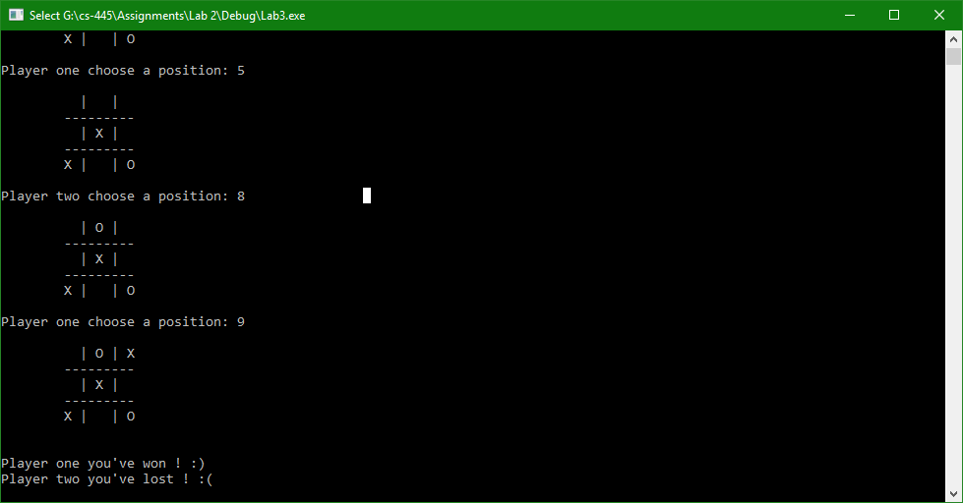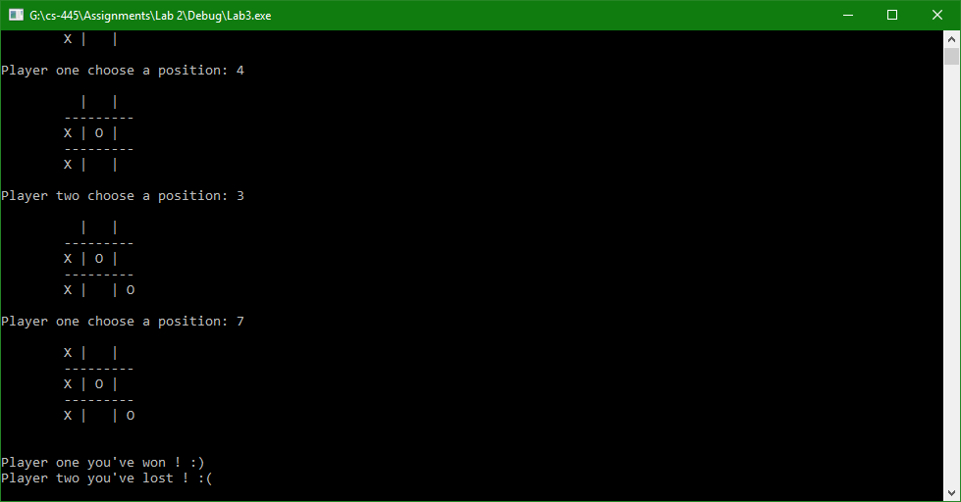

PROGRAM LISTING
6) Copy and paste the code that YOU typed to make the program work. Your program should include a comment block at the top that shows the name of the program, date, version and your name.
(main.cpp)
//===========================================
// Program Lab 2
// 1-31-2018
// Edgar Hernandez
//===========================================

#include <iostream>
#include <vector>
#include <limits>

#include "TicTacToe.h"

using namespace std;

const char X = 'X';
const char O = 'O';

int main()
{
TicTacToe game;
game.displayInfo();
game.Answer();

while (game.winner() == game.noWinner())
{
if (game.getAnswer() == 'y')
{
game.displayBoard();
game.playerOne(X, O);
if (game.isBoardFull()) { break; };
if (game.winner() == game.playerOneSign(X, O))
{
game.displayBoard();
break;
};
game.displayBoard();
game.PlayerTwo(X, O);
}
else
{
game.PlayerTwo(X, O);
game.displayBoard();
if (game.isBoardFull()) { break; };
if (game.winner() == game.PlayerTwoSign(X, O))
{
game.displayBoard();
break;
};
game.playerOne(X, O);
game.displayBoard();
}
}
game.displayWinner(X, O);
cin.ignore(numeric_limits<streamsize>::max(), '\n');
cin.get();

return EXIT_SUCCESS;
}

(TicTacToe.cpp)
#include <iostream>
#include <vector>
#include <string>

#include "TicTacToe.h"

using namespace std;

TicTacToe::TicTacToe()
: question("\nPlayer one would you like to be the first to begin (Y/N): ")
, empty(' ')
, draw('D')
, no_winner('N')
, answer(' ')
, max_pos(9)
, min_pos(1)
{
// fill the vector with spaces
for (int i = 0; i < 9; ++i)
{
board.push_back(empty);
}
}

void TicTacToe::displayInfo()
{
cout << "To make your move enter a number (1 - 9), \n";

cout << "7 | 8 | 9\n";
cout << "---------\n";
cout << "4 | 5 | 6\n";
cout << "---------\n";
cout << "1 | 2 | 3\n\n";
}

void TicTacToe::displayBoard()
{
cout << "\n\t" << board[6] << " | " << board[7] << " | " << board[8];
cout << "\n\t" << "---------";
cout << "\n\t" << board[3] << " | " << board[4] << " | " << board[5];
cout << "\n\t" << "---------";
cout << "\n\t" << board[0] << " | " << board[1] << " | " << board[2];
cout << endl << endl;
}

void TicTacToe::Answer()
{
do
{
cout << this->question;
cin >> this->answer;

// transform the input to lower case
answer = towlower(answer);

} while (answer != 'y' && answer != 'n');
}

char TicTacToe::playerOneSign(const char X, const char O)
{
if (this->answer == 'y')
{
return X;
}
else
{
return O;
}
}

char TicTacToe::PlayerTwoSign(const char X, const char O)
{
char getPlayerOneSign = playerOneSign(X, O);

if (getPlayerOneSign == X)
{
return O;
}
else
{
return X;
}
}

bool TicTacToe::isLegalMove(int move)
{
return (board[move - 1] == empty);
}
char TicTacToe::winner()
{
const int MAX_ROWS = 8;
//all possible winning pairs
const int WINNING_PAIRS[MAX_ROWS][3] = { { 0, 1, 2 },
{ 3, 4, 5 },
{ 6, 7, 8 },
{ 0, 3, 6 },
{ 1, 4, 7 },
{ 2, 5, 8 },
{ 2, 4, 6 },
{ 0, 4, 8 }
};
// check for 3 equal values
for (int row = 0; row < MAX_ROWS; ++row)
{
if ((board[WINNING_PAIRS[row][0]] != empty) &&
(board[WINNING_PAIRS[row][0]] == board[WINNING_PAIRS[row][1]]) &&
(board[WINNING_PAIRS[row][1]] == board[WINNING_PAIRS[row][2]]))
{
return board[WINNING_PAIRS[row][0]];
}
}
// return if the game is draw
if (count(board.begin(), board.end(), empty) == 0)
{
return draw;
}
return no_winner;
}
//Player one
void TicTacToe::playerOne(const char X, const char O)
{
int move;

do
{
cout << "Player one choose a position: ";
cin >> move;
if (!cin)
{
cerr << "\nWrong input !\n";
cin.clear();
cin.ignore();
}
} while (move > max_pos || move < min_pos || !isLegalMove(move));
board[move - 1] = playerOneSign(X, O);
}
//Player two
void TicTacToe::PlayerTwo(const char X, const char O)
{
int move;
do
{
cout << "Player two choose a position: ";
cin >> move;
if (!cin)
{
cerr << "\nWrong input !\n";
cin.clear();
cin.ignore();
}
} while (move > max_pos || move < min_pos || !isLegalMove(move));
board[move - 1] = PlayerTwoSign(X, O);;
}

void TicTacToe::displayWinner(const char X, const char O)
{
char plaOne = playerOneSign(X, O);
char plaTwo = PlayerTwoSign(X, O);

if (plaOne == winner())
{
cout << "\nPlayer one you've won ! :) " << endl;
cout << "Player two you've lost ! :( " << endl;
}
else if (plaTwo == winner())
{
cout << "\nPlayer two you've won ! :) " << endl;
cout << "Player one you've lost ! :( " << endl;
}
else
{
cout << "The game is DRAW !" << endl;
}
}

bool TicTacToe::isBoardFull()
{
if (count(board.begin(), board.end(), empty) == 0)
{
return true;
}
else
{
return false;
}
}

(TicTacToe.h)

#include <iostream>
#include <vector>
#include <string>

#include "TicTacToe.h"

using namespace std;

TicTacToe::TicTacToe()
: question("\nPlayer one would you like to be the first to begin (Y/N): ")
, empty(' ')
, draw('D')
, no_winner('N')
, answer(' ')
, max_pos(9)
, min_pos(1)
{
// fill the vector with spaces
for (int i = 0; i < 9; ++i)
{
board.push_back(empty);
}
}

void TicTacToe::displayInfo()
{
cout << "To make your move enter a number (1 - 9), \n";

cout << "7 | 8 | 9\n";
cout << "---------\n";
cout << "4 | 5 | 6\n";
cout << "---------\n";
cout << "1 | 2 | 3\n\n";
}

void TicTacToe::displayBoard()
{
cout << "\n\t" << board[6] << " | " << board[7] << " | " << board[8];
cout << "\n\t" << "---------";
cout << "\n\t" << board[3] << " | " << board[4] << " | " << board[5];
cout << "\n\t" << "---------";
cout << "\n\t" << board[0] << " | " << board[1] << " | " << board[2];
cout << endl << endl;
}

void TicTacToe::Answer()
{
do
{
cout << this->question;
cin >> this->answer;

// transform the input to lower case
answer = towlower(answer);

} while (answer != 'y' && answer != 'n');
}

char TicTacToe::playerOneSign(const char X, const char O)
{
if (this->answer == 'y')
{
return X;
}
else
{
return O;
}
}

char TicTacToe::PlayerTwoSign(const char X, const char O)
{
char getPlayerOneSign = playerOneSign(X, O);

if (getPlayerOneSign == X)
{
return O;
}
else
{
return X;
}
}

bool TicTacToe::isLegalMove(int move)
{
return (board[move - 1] == empty);
}
char TicTacToe::winner()
{
const int MAX_ROWS = 8;
//all possible winning pairs
const int WINNING_PAIRS[MAX_ROWS][3] = { { 0, 1, 2 },
{ 3, 4, 5 },
{ 6, 7, 8 },
{ 0, 3, 6 },
{ 1, 4, 7 },
{ 2, 5, 8 },
{ 2, 4, 6 },
{ 0, 4, 8 }
};
// check for 3 equal values
for (int row = 0; row < MAX_ROWS; ++row)
{
if ((board[WINNING_PAIRS[row][0]] != empty) &&
(board[WINNING_PAIRS[row][0]] == board[WINNING_PAIRS[row][1]]) &&
(board[WINNING_PAIRS[row][1]] == board[WINNING_PAIRS[row][2]]))
{
return board[WINNING_PAIRS[row][0]];
}
}
// return if the game is draw
if (count(board.begin(), board.end(), empty) == 0)
{
return draw;
}
return no_winner;
}
//Player one
void TicTacToe::playerOne(const char X, const char O)
{
int move;

do
{
cout << "Player one choose a position: ";
cin >> move;
if (!cin)
{
cerr << "\nWrong input !\n";
cin.clear();
cin.ignore();
}
} while (move > max_pos || move < min_pos || !isLegalMove(move));
board[move - 1] = playerOneSign(X, O);
}
//Player two
void TicTacToe::PlayerTwo(const char X, const char O)
{
int move;
do
{
cout << "Player two choose a position: ";
cin >> move;
if (!cin)
{
cerr << "\nWrong input !\n";
cin.clear();
cin.ignore();
}
} while (move > max_pos || move < min_pos || !isLegalMove(move));
board[move - 1] = PlayerTwoSign(X, O);;
}

void TicTacToe::displayWinner(const char X, const char O)
{
char plaOne = playerOneSign(X, O);
char plaTwo = PlayerTwoSign(X, O);

if (plaOne == winner())
{
cout << "\nPlayer one you've won ! :) " << endl;
cout << "Player two you've lost ! :( " << endl;
}
else if (plaTwo == winner())
{
cout << "\nPlayer two you've won ! :) " << endl;
cout << "Player one you've lost ! :( " << endl;
}
else
{
cout << "The game is DRAW !" << endl;
}
}

bool TicTacToe::isBoardFull()
{
if (count(board.begin(), board.end(), empty) == 0)
{
return true;
}
else
{
return false;
}
}

